**Picture Description**

Picture descriptions can define photos, graphics, gifs, and video — basically anything containing visual information.

**Elements of Picture Description**

1. Introduction
2. Layout
3. Describing people
4. Atmosphere of picture
5. Your opinion, feelings, emotions
6. Comparison of pictures

**1. Introduction**

**Vocabulary used in introduction:**

In the picture I can see…….

The picture shows……..

This is a picture of………….

There is/are ……….in the picture.

The picture is from…………

**Examples:**

In the picture, I can see a sunny countryside.

The picture shows the countryside in summer.

**2. Layout**

1.

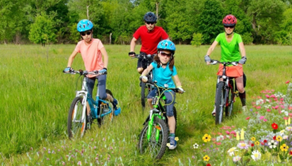

In the foreground, we can see some people on bikes.

2.

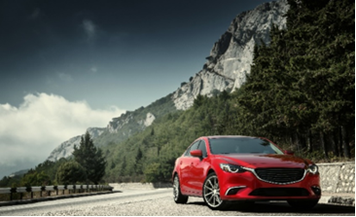

In the background we can see some mountains.

**3.**

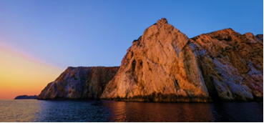

In the middle of the picture there are some huge stones.

**4.**

On the right there is an armchair. 
On the left there are frames on the wall. 

On the right there is an armchair.

On the left there are frames on the wall.

**3. Describing People**

You should answer the following questions:

* How many people are there?
* Who are they?
* What are they doing?
* What are they wearing?
* How are they feeling?

**Examples:**

1.



There are five people in the picture.

2. 

I think they are friends.

3.

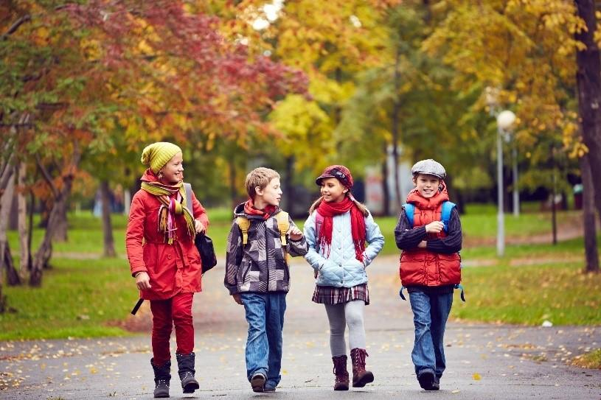

Kids are playing in the park.

**4. Atmosphere of The Picture**

* Positive
* Funny
* Pleasant
* Unusual
* Strange
* Relaxed
* Nervous
* Happy
* Sad
* Boring
* Quiet
* Loud
* Crazy
* Excited

**Examples:**

1.



The atmosphere of this picture is positive as people are smiling.

2.

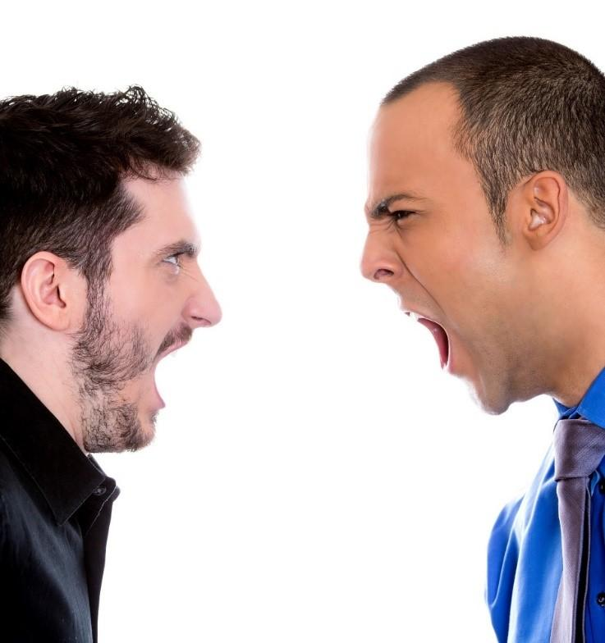

The atmosphere of the above picture is negative as people are shouting at each other.

**5. Your Opinion**

**Vocabulary used in your opinion:**

* I think that…..
* In my opinion….
* It seems to me that ……
* Perhaps……
* Maybe…..

**Examples:**

1.

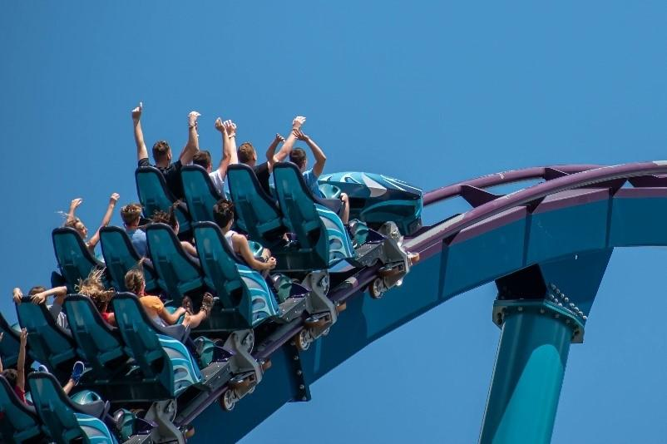

I think the people in the picture are on a holiday because…….

2. 

In my opinion the woman in the picture is sad because…….

**6. Comparison**

1.

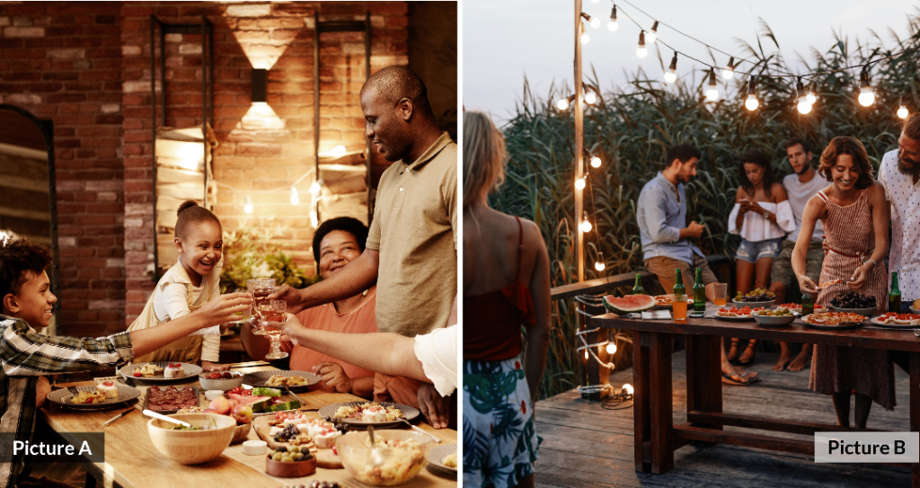

Both the pictures show party, but the party in picture A takes place inside whereas the party in picture B takes place outside.

2.

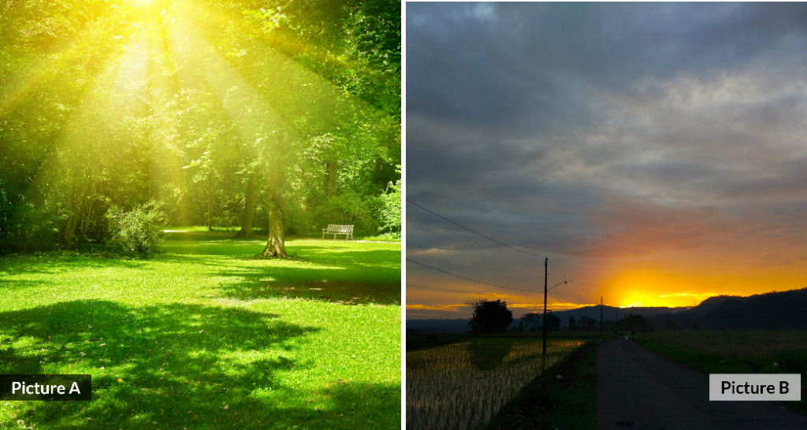

The weather in picture A is more pleasant than picture B.

**Don’t:**

* Panic if you don’t know the words for all the things in the picture. You *don’t* need to know all the words for everything in the picture if you know what to say when you don't know an exact word.
* Get distracted and start talking about something else. Focus on the photo or picture.
* Panic if your mind goes blank. Take a deep breath, look at the picture and start again.

If you are asked to describe a photo or a picture in the exam, here is some language you can use:

**What is in the picture?**

*In the picture I can see ...  
There’s / There are ...  
There isn’t a ... / There aren’t any ...*

**Say what is happening with the present continuous**

*The man is ...ing  
The people are ...ing  
It’s raining.*

**Where in the picture?**

*At the top/bottom of the picture ...  
In the middle of the picture ...  
On the left/right of the picture ...  
next to  
in front of  
behind  
near  
on top of  
under*

**If something isn’t clear**

*It looks like a ...  
It might be a ...  
He could be ...ing  
Maybe it’s a ...*

<https://manwrites.com/how-to-describe-a-picture-in-english/>